**Course _______Specialist______ Year __12_____**

Student name: ________________ Teacher name: ________________

Date: 21 Aug Fri

**Task type: Response**

**Time allowed for this task: _____45______ mins**

**Number of questions: _____6______**

**Materials required: NO CLASSPADS/CALS**

Standard items: Pens (blue/black preferred), pencils (including coloured), sharpener, correction fluid/tape, eraser, ruler, highlighters

Special items: Drawing instruments, templates, , and up to three calculators approved for use in the WACE examinations

**NO NOTES ALLOWED**

**Marks available: __39____ marks**

**Task weighting: _12___%**

**Formula sheet provided: Yes**

**Note: All part questions worth more than 2 marks require working to obtain full marks.**

**Q1 (4.1.2) (3, 3 & 3 = 9 marks)**

Determine the following integrals showing full working.

1. 
2. 
3. 

**Q2 (4.1.1 -4.1.3) (3, 3 & 3 = 9 marks)**

Determine the following definite integrals showing full working.

1. 
2. 
3. 

**Q3 (4 marks)**

Determine the following integral showing full working.



**Q4 (4.1.5-4.1.6) (5 marks)**

Consider a cylindrical drill of width 2 cm that carves a cavity inside a solid sphere of radius 5 cm as shown below. Determine the volume of the sphere remaining.(Simplify)

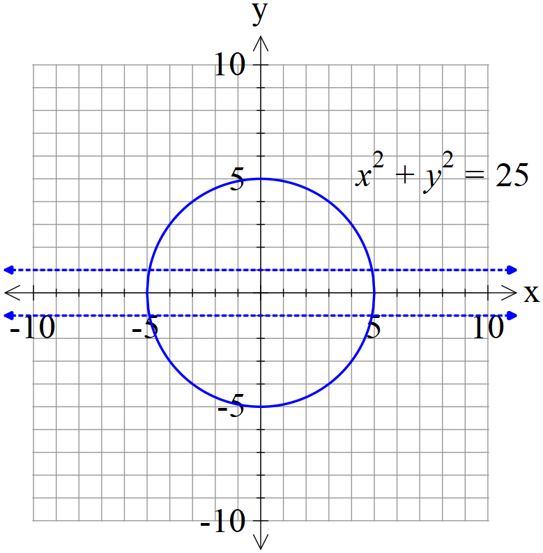

**Q5 (4.2.4) (4 marks)**

Determine the solution to the following differential equation  given that (1,1) is a known point.(No need to simplify)

**Q6 (4.2.6) (1, 5 & 2 = 8 marks)**

Consider the differential equation  with  positive constants.

1. Determine the limiting value for  as 
2. Show how to derive using integration and partial fractions that the general solution is 
3. Consider  with an initial value of . Determine  when t=50.

(No need to simplify)

.